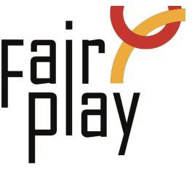

SUBMISSION OF CANDIDACY QUESTIONNAIRE FOR C.I.F.P. AWARDS
NOMINATIONS FOR THE YEAR 2025

Willi Daume World Fair Play Trophy – 2025

Willi Daume World Fair Play Trophy to a person or organization for an activity aiming at promoting Fair Play by organizing national or local campaigns, giving lectures, writing articles in the press, or making comments on the radio or television.

1. Details of the person or organization proposed for the nomination:
Ms./Mr./organization *
Ms.
Mr.
Organization
Name: *
Country: *
E-mail: *
Profession or current occupation: *

2. Description activities promoting fair play:

Local level: (max. 50 words):

(Inter)national level: (max. 50 words):

3. Description connection with aspects of fair play: *

4. Source (preferably in English): *

5. Details of the person or organization submitting this nomination:

Name: *
E-mail: *

Please attach all available supporting evidence (photos, press clippings, reports etc.) justifying this nomination as well as a PHOTO

